
National Textile University
Department of Computer Science
Subject:
Mobile Application Development
Submitted To:
Sir Rehan Sarwar
Submitted By:
Alishba Riasat
Registration No:
23-NTU-CS-1135
Lab No:
01
Semester:
6th

Task No.1:

Create a project
Task No.2:

Create a Stateless Widget (stle) and Add AppBar to your Project.
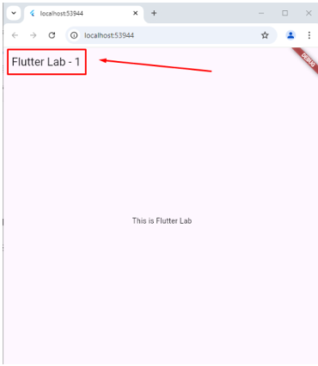

Code:
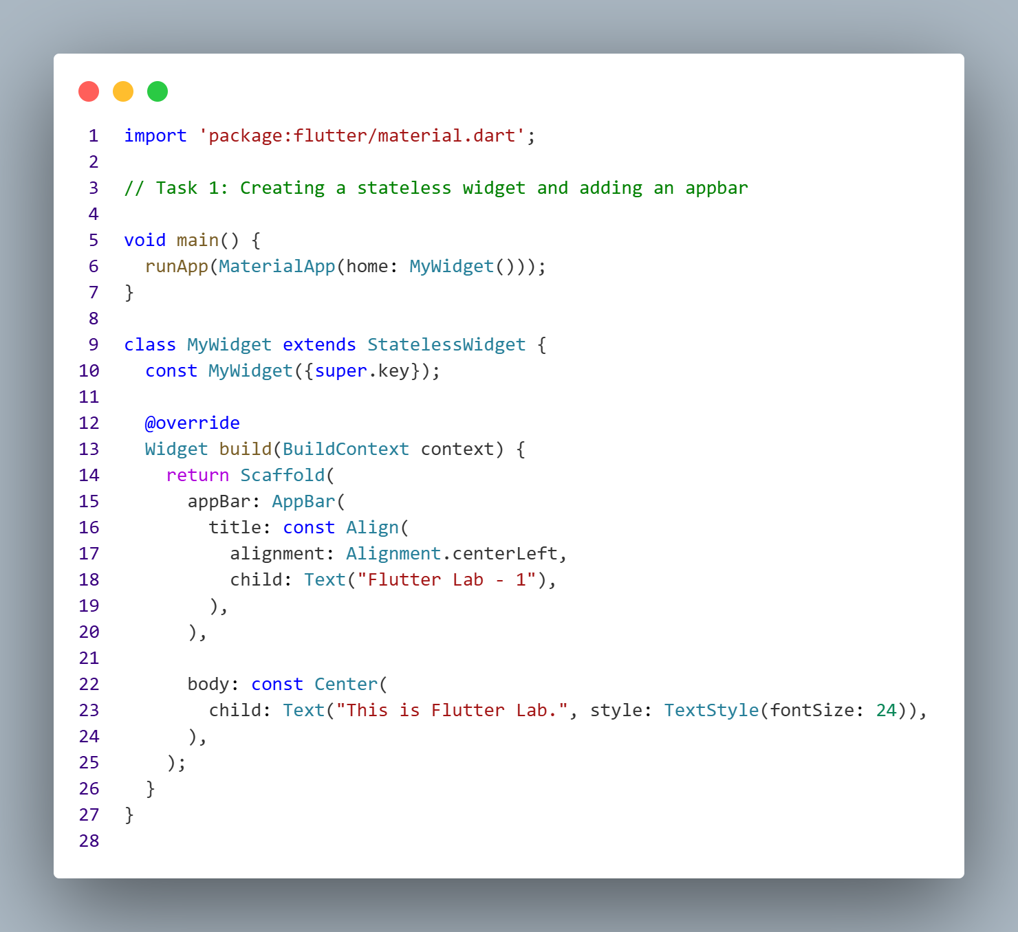

Output:
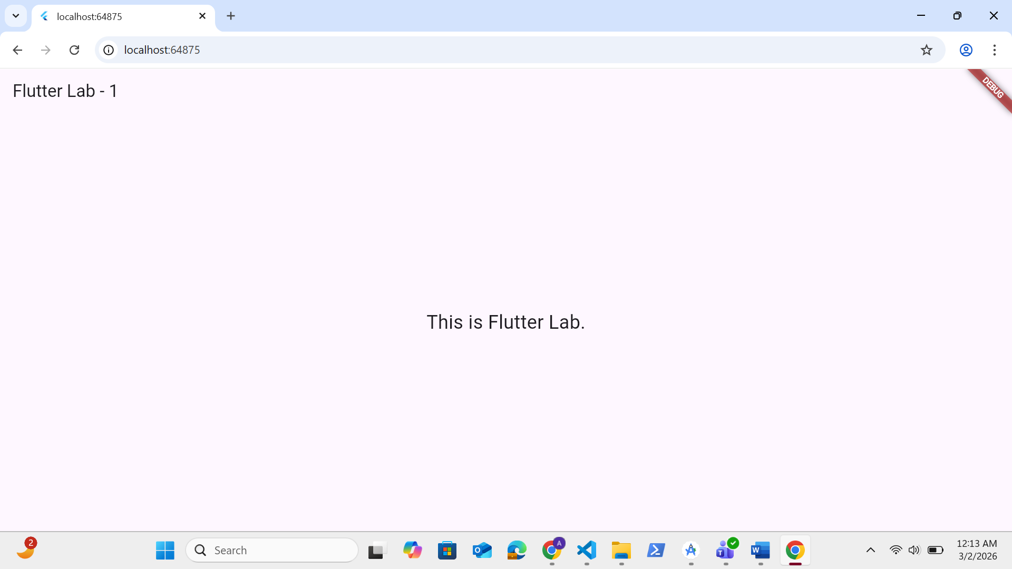
Task No.3:

Change the color of the Appbar.
Code:
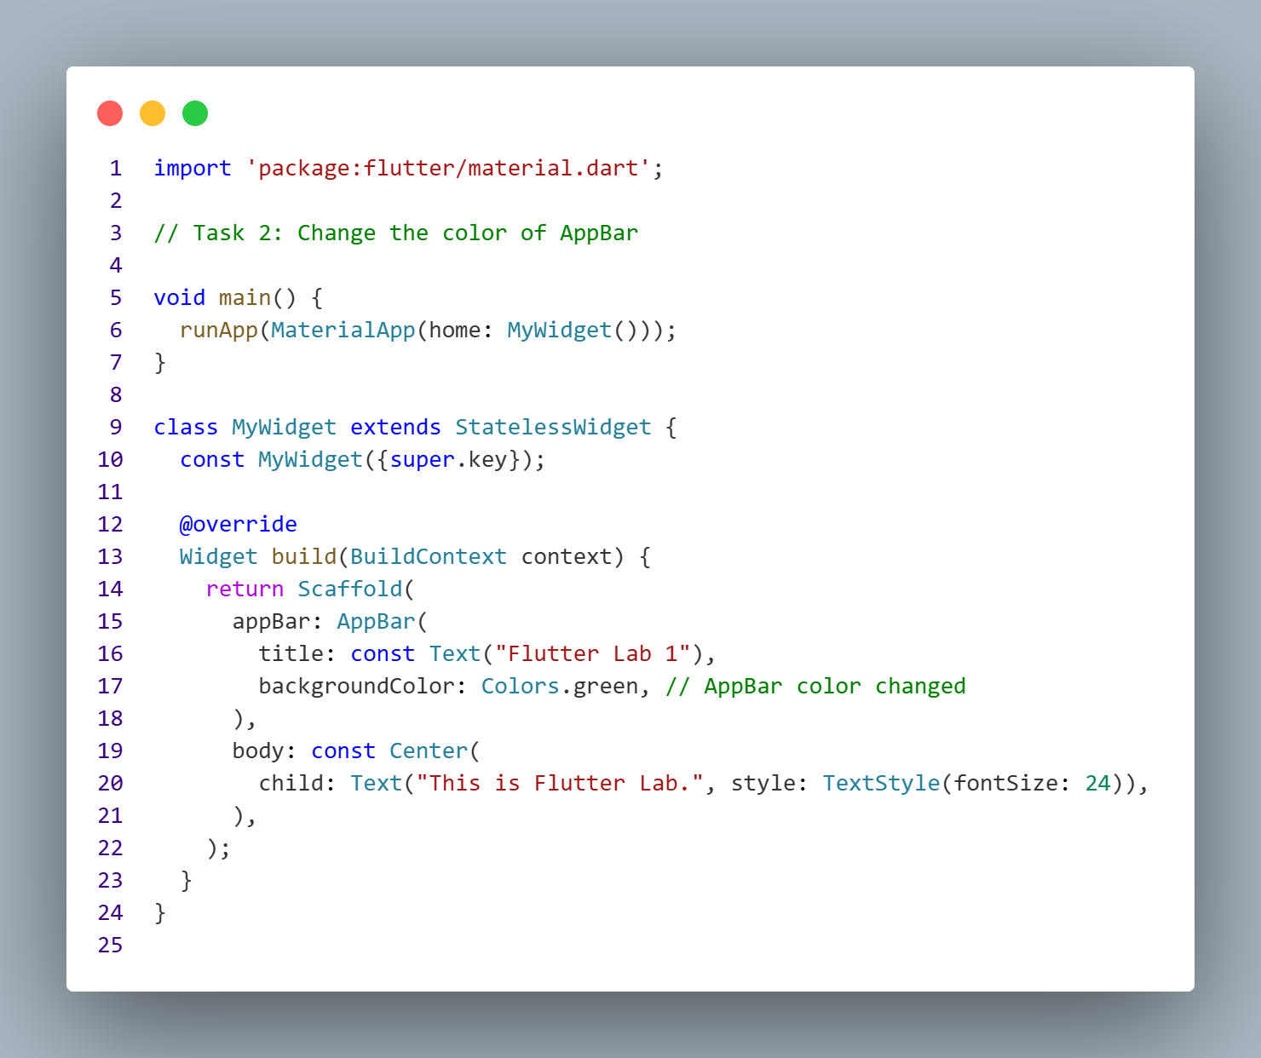
Output:
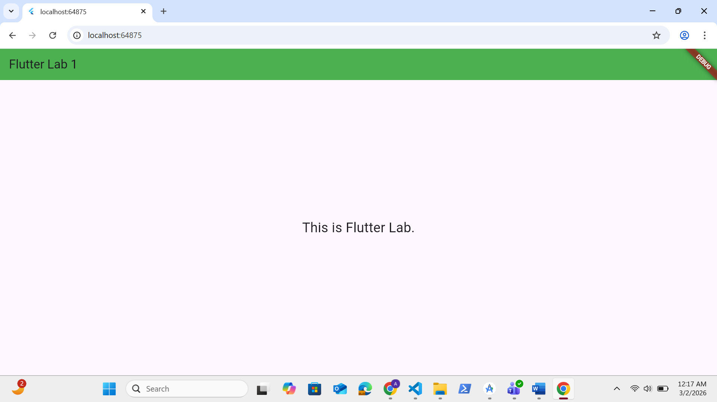
Task No.4:
Align the Text on the Appbar at center.
Code:
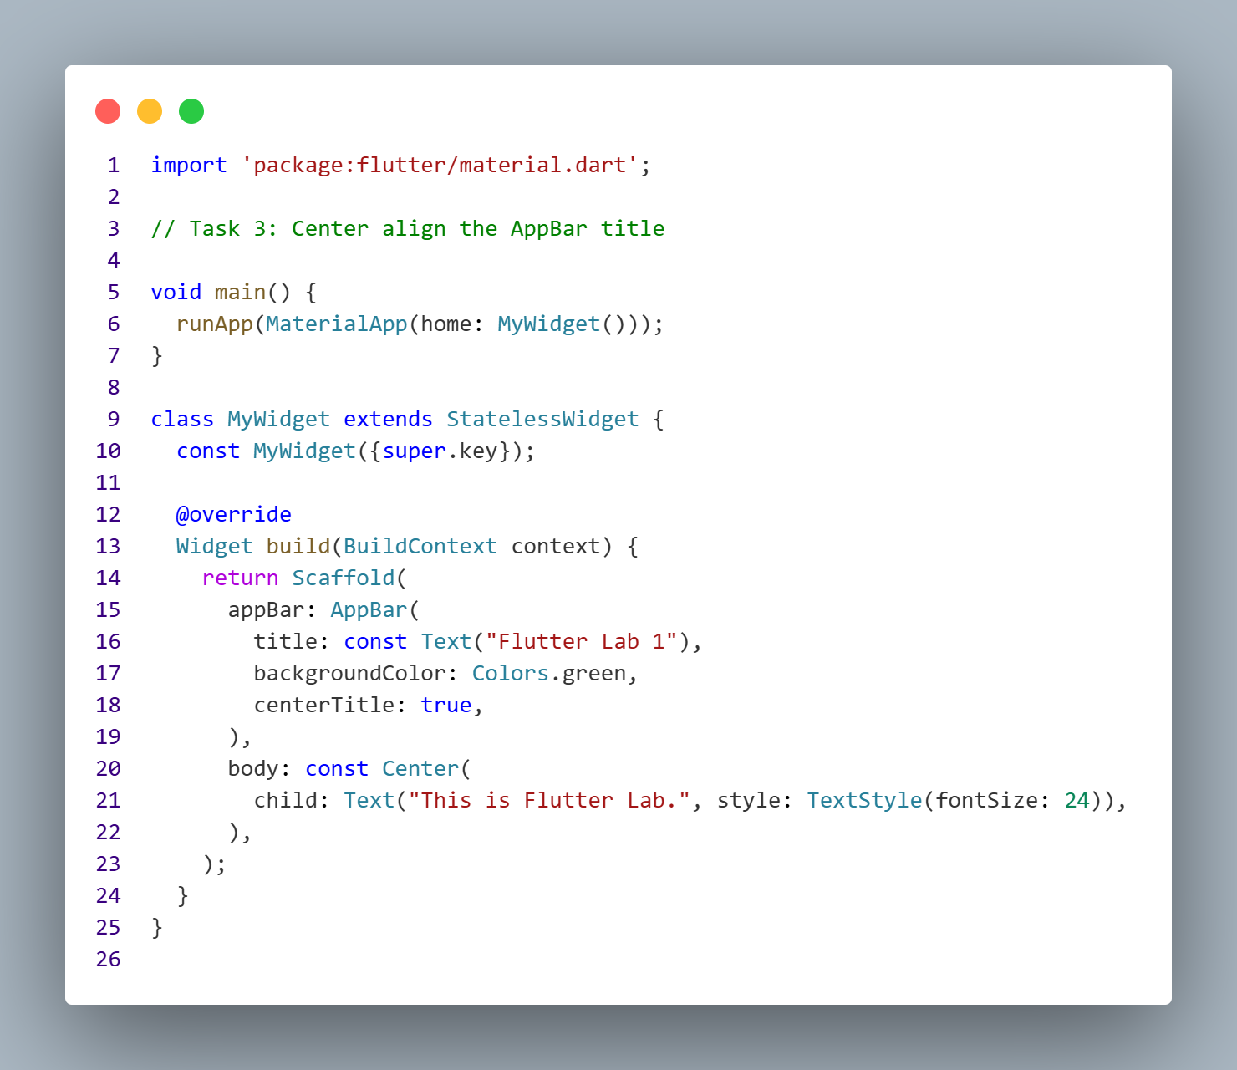
Output:
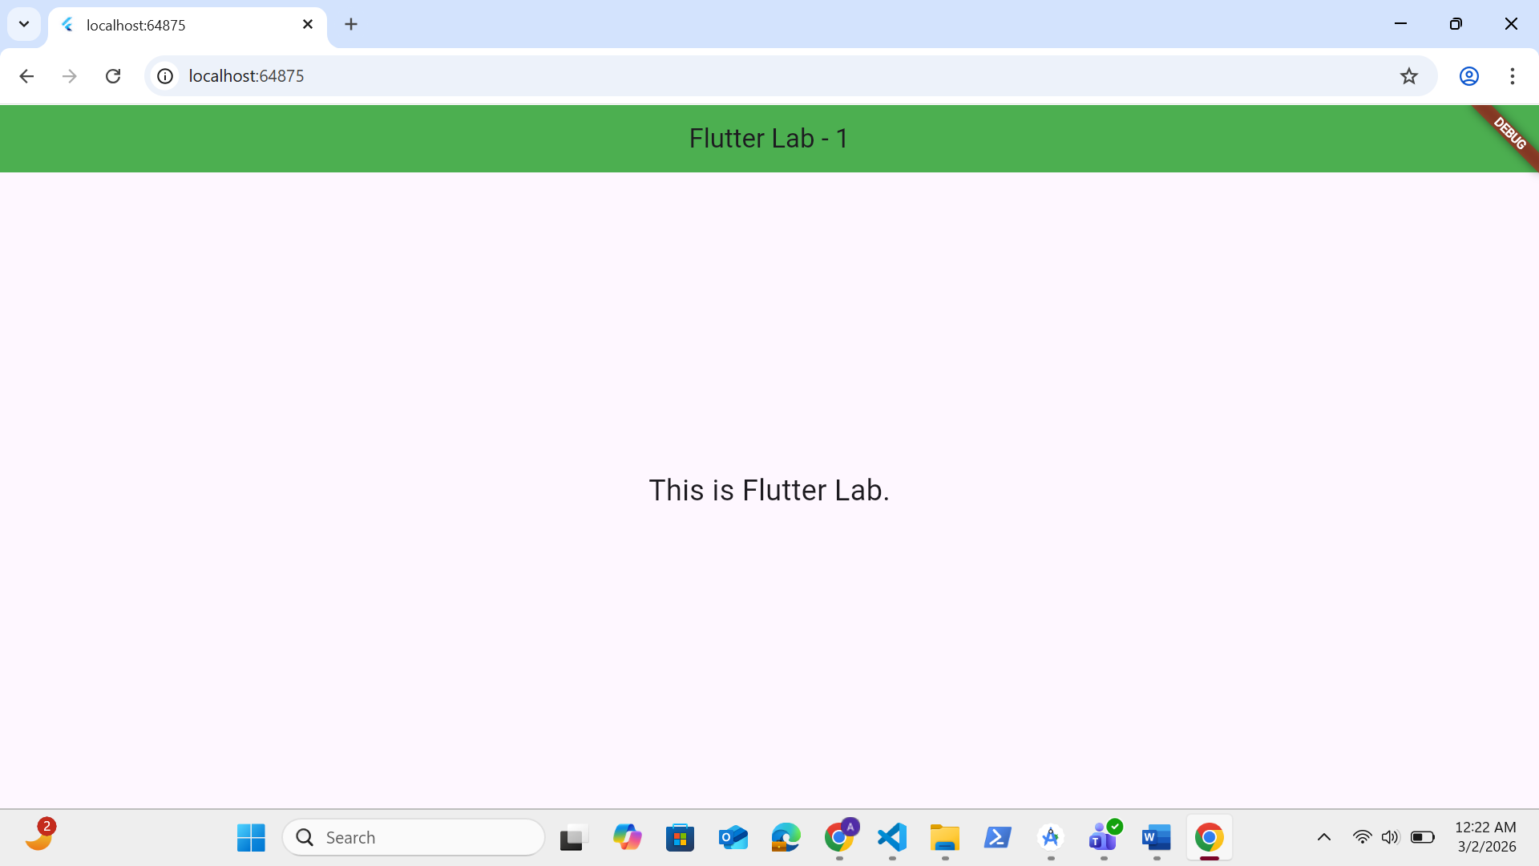
Task No.5:
Add you name at the center of the screen.
Code:
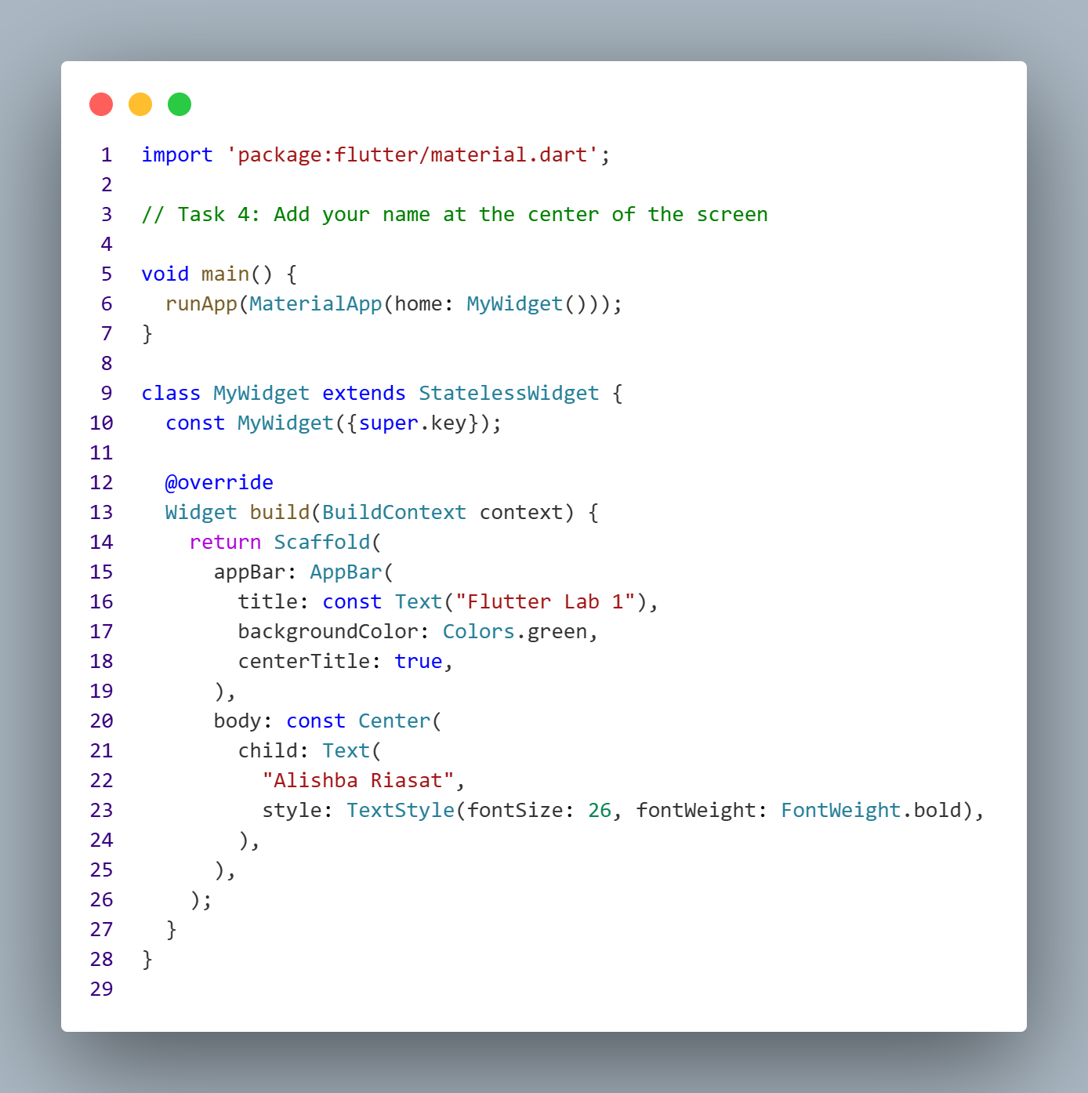
Output:
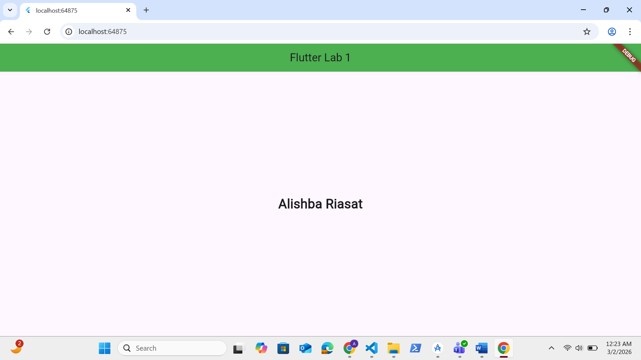

Task No.6 & 7:

Create a Stateless Widget (stle) and Add AppBar to your Project.
Code:
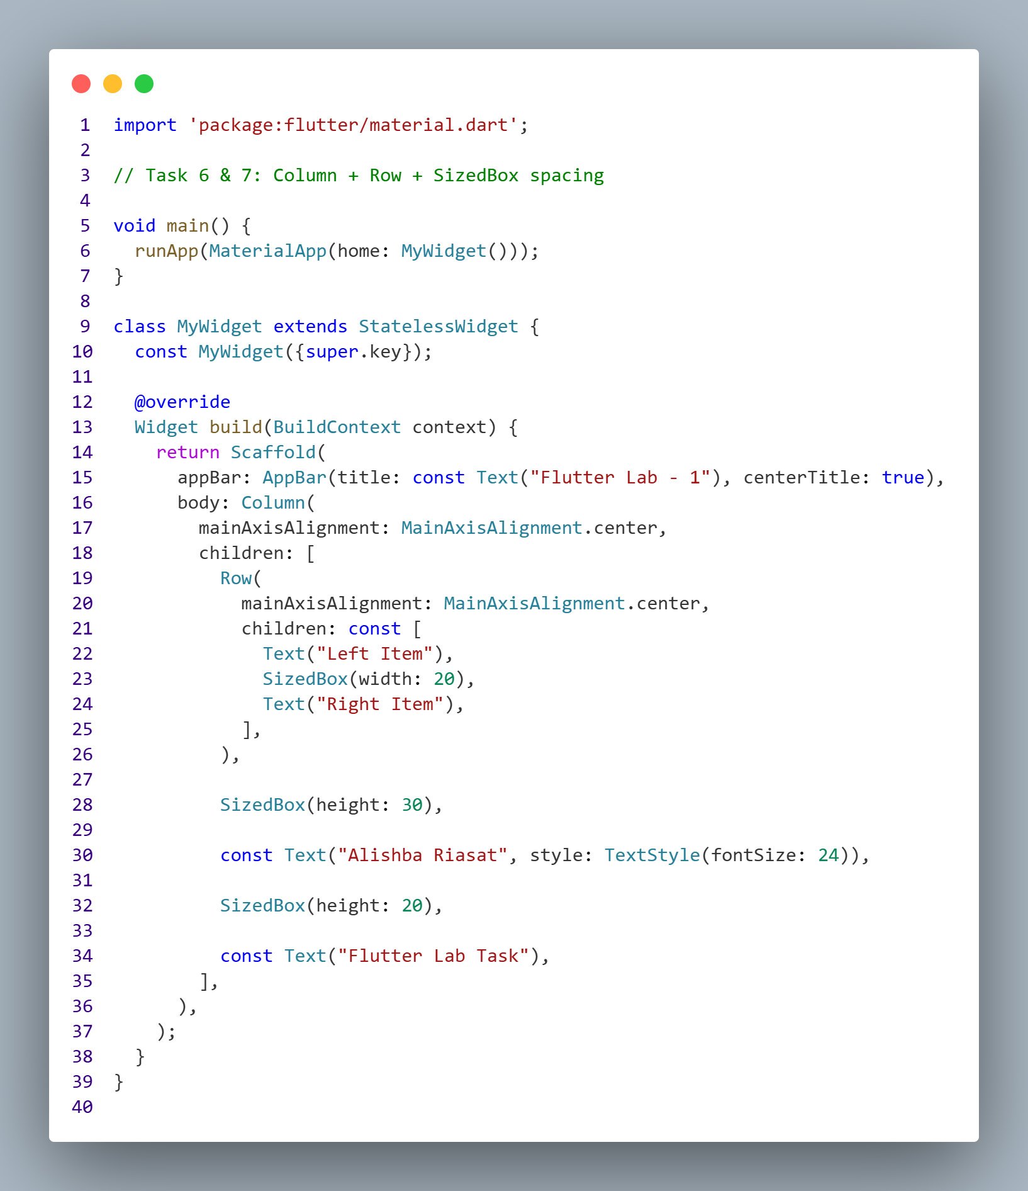
Output:
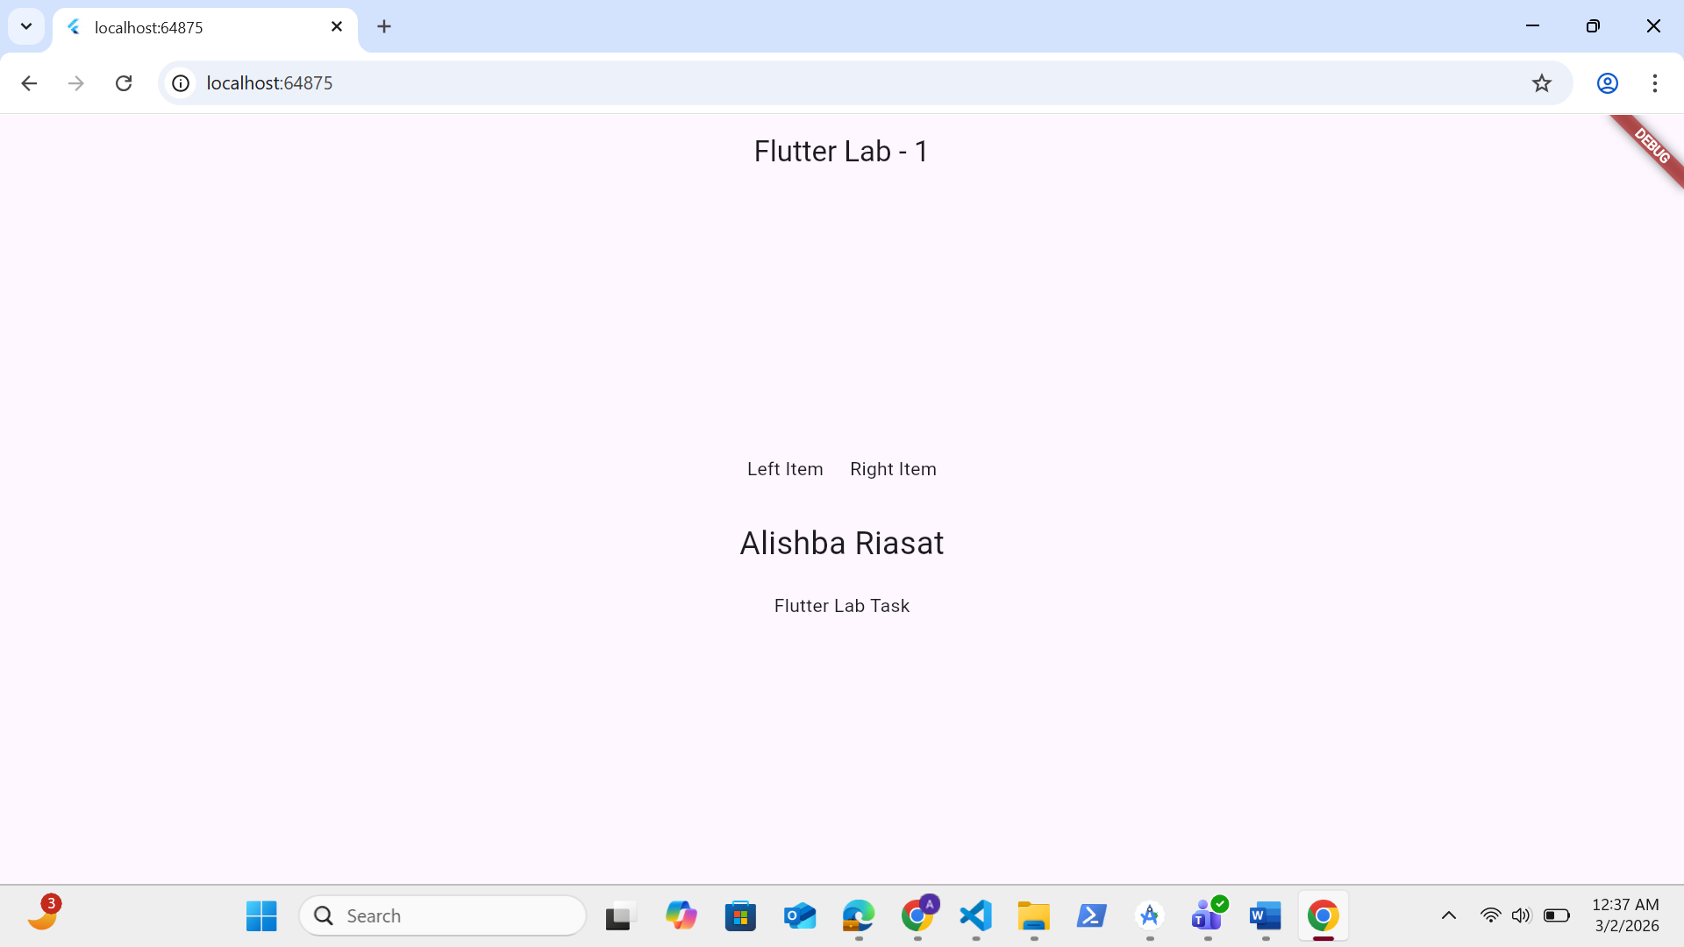
Task No.8 & 9:

Download the image from google
- Add assets to pubspec.yml file
Add Image to your project by using assets
Code:
pubspec.yml
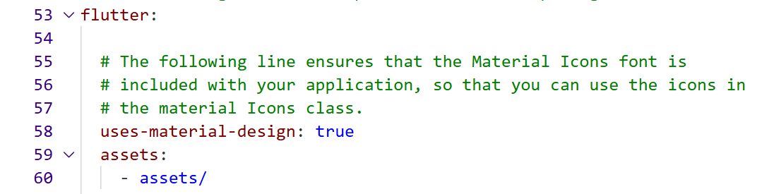
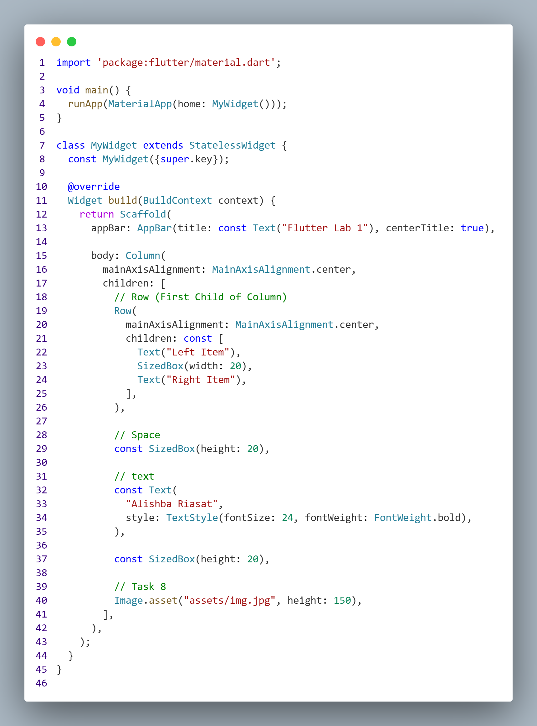

Output:
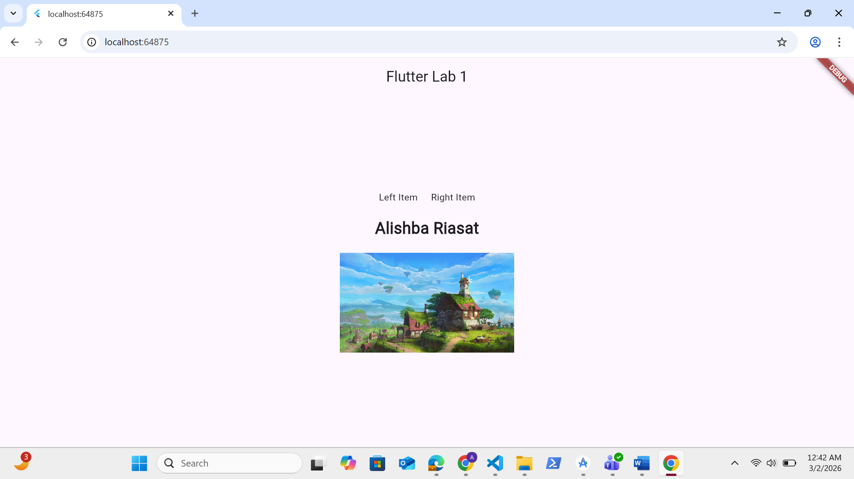

Task No.10:
Add Image to your project by using Network Image
Code:
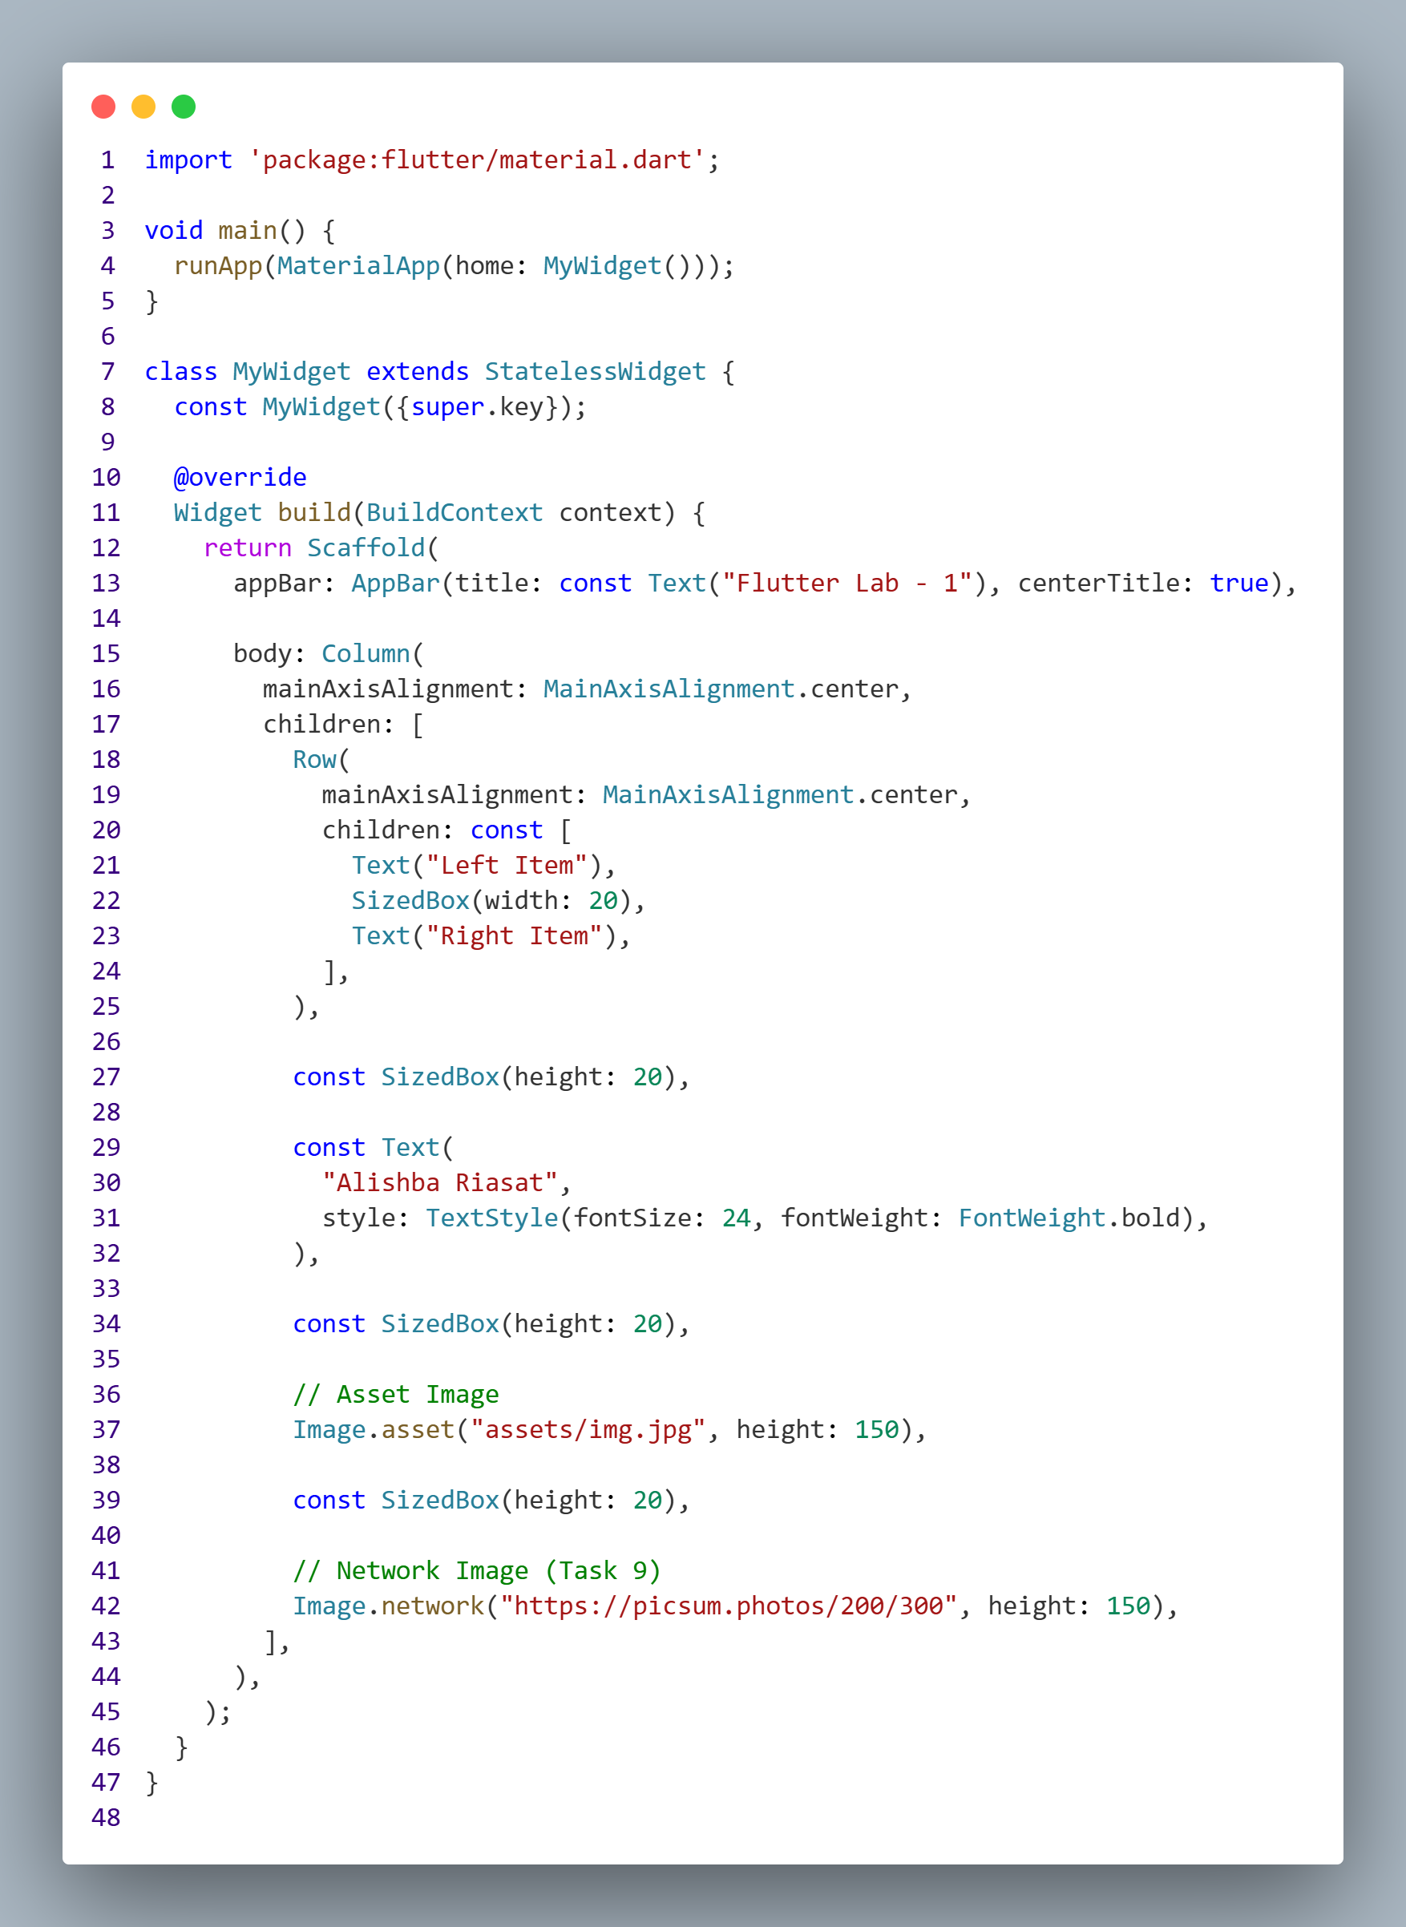
Output:
